

TEMPLATE REPORT

REVERSE BINARY



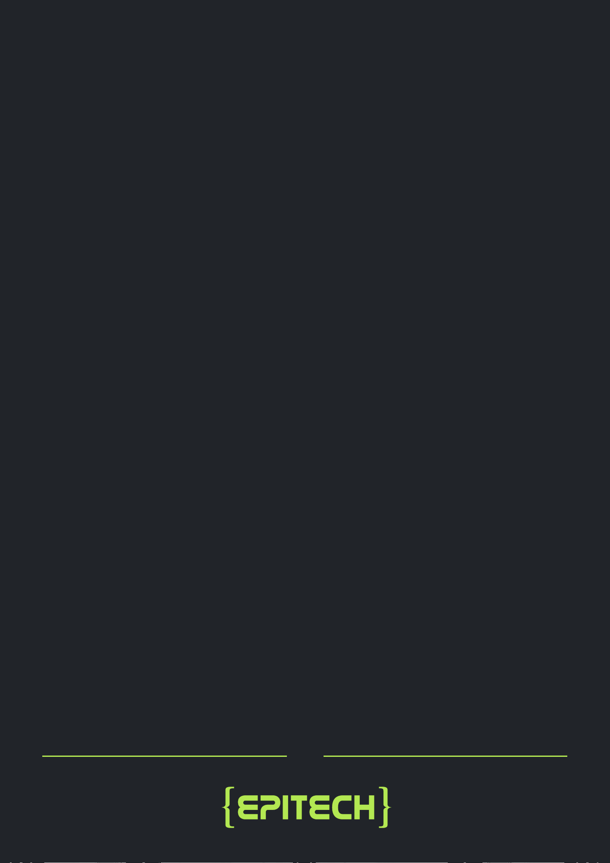TEMPLATE REPORT

# Table of Contents

1. Black-box Audit
2. White-box Audit
3. Vulnerability Report
4. Conclusion

# Black-box Audit

In this phase, we analyzed the binary using reverse engineering tools and manual fuzzing. List of the tools you used:

* [insert tool #1]
* [insert tool #2]
* [insert tool #3]

Key discoveries:

* [Insert summary of findings or points of interest]
* [Add any PoC or manual fuzzing outcomes]

# White-box Audit

With access to source code, we performed a full code review and vulnerability assessment. Focus areas:

* Input validation
* Memory safety (heap/stack misuse)
* Format string handling
* Privilege escalation paths

Additional vulnerabilities discovered:

* [Insert findings here]

List of the tools you used:

* [insert tool #1]
* [insert tool #2]

1

* [insert tool #3]

# Vulnerability Report

Below is the list of vulnerabilities discovered, ranked by severity:

## Vulnerability #1: [Name]

Severity: Critical

Type: [Buffer Overflow, Format String, etc.] Location: src/[file].c, function [function_name] Discovered in: Black-box / White-box

Description:

[Insert detailed explanation here.]

Proof of Concept:

[Insert how to get the exploit]

Impact:

[e.g., Remote Code Execution, Segmentation Fault, Privilege Escalation. . . ]

Fix Summary:

* [Describe what was fixed and how]
* Patch file: src/[file].c.patch

Unit Test: Yes / No

Test Coverage: 100% / Partial

## Vulnerability #2: [Name]

Severity: High Type: [. . . ]

[Repeat same format as above]

2

# Conclusion

* + Total vulnerabilities found: [#]
  + All were successfully patched.
  + Each patch was validated via unit tests.
  + Final code is secure, maintainable, and ready for deployment.

Vulnerability Name | Patch File | Unit Tested | Coverage

- - - - - - - - - - - - - - - |- - - - - - - - - - -| - - - - - - - - - - |- - - - -

[Vuln 1 Name] - - - - | file.c.patch - -| Yes | 100%

[Vuln 2 Name] - - - - | utils.c.patch -| Yes | 95%

3

v 1.O

